**EXP:4 CREATE A WEB PAGE TO ACCEPT USERNAME AND AGE AND**

**DISPLAY IT ON BROWSER**

**AIM:**

Create a web form that accepts a user's name and age. Write a Servlet to process the form data and display it back on the browser.

**CODE:**

**INDEX.HTML**

<!DOCTYPE html>

<html>

<head>

    <title>Sign Up</title>

</head>

<body>

    <h1>Sign Up Page</h1>

    <form action="/Pavithra/DisplayUser">

        <label for="username">Username:</label><br>

        <input type="text" id="username" name="username"><br><br>

        <label for="age">Age:</label><br>

        <input type="number" id="age" name="age" min="0"><br><br>

        <button type="submit">Sign Up</button>

    </form>

</body>

</html>

**DISPLAYUSER.JAVA**

package com.pavithra.servlet;

import java.io.IOException;

import java.io.PrintWriter;

import javax.servlet.ServletException;

import javax.servlet.annotation.WebServlet;

import javax.servlet.http.HttpServlet;

import javax.servlet.http.HttpServletRequest;

import javax.servlet.http.HttpServletResponse;

/**

 * Servlet implementation class DisplayUser

 */

@WebServlet("/DisplayUser")

public class DisplayUser extends HttpServlet {

private static final long serialVersionUID = 1L;

    /**

     * @see HttpServlet#HttpServlet()

     */

    public DisplayUser() {

        super();

        // TODO Auto-generated constructor stub

    }

                   /**

* @see HttpServlet#doGet(HttpServletRequest request, HttpServletResponse response)

*/

protected void doGet(HttpServletRequest request, HttpServletResponse response) throws ServletException, IOException {

String a=request.getParameter("username");

int b=Integer.parseInt(request.getParameter("age"));

PrintWriter p=response.getWriter();

if(b<=0){

p.println("Login failed");

}

else {

p.println(a);

p.println(b);

}

}

/**

* @see HttpServlet#doPost(HttpServletRequest request, HttpServletResponse response)

*/

protected void doPost(HttpServletRequest request, HttpServletResponse response) throws ServletException, IOException {

// TODO Auto-generated method stub

doGet(request, response);

}

}

**OUTPUT**:

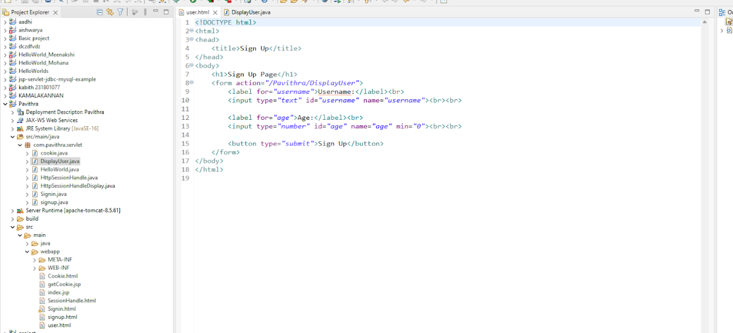

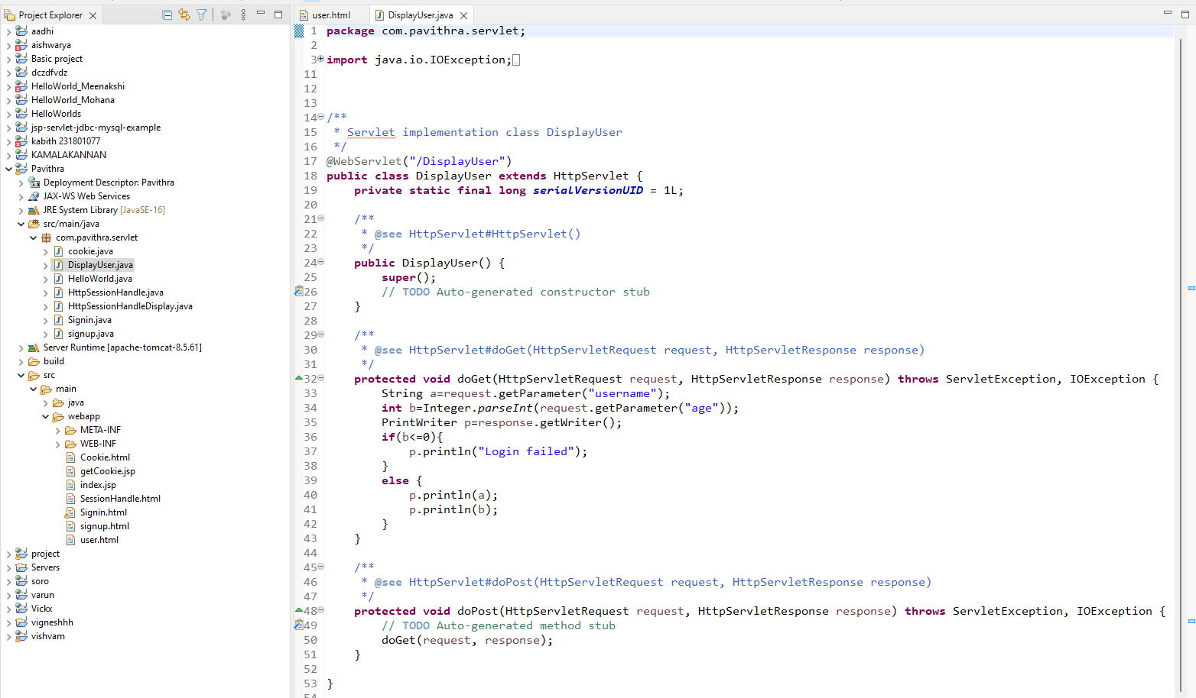

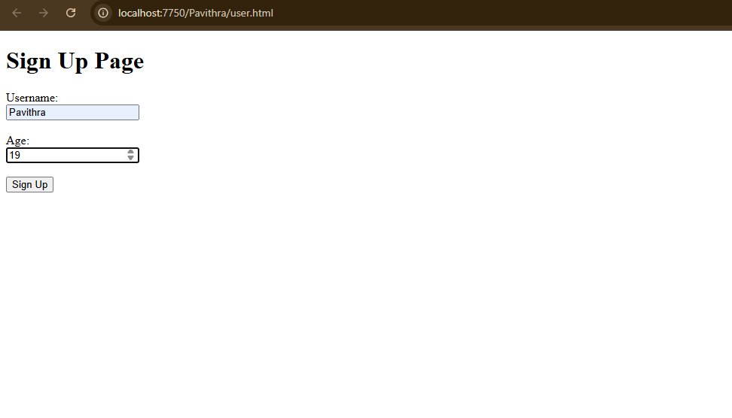

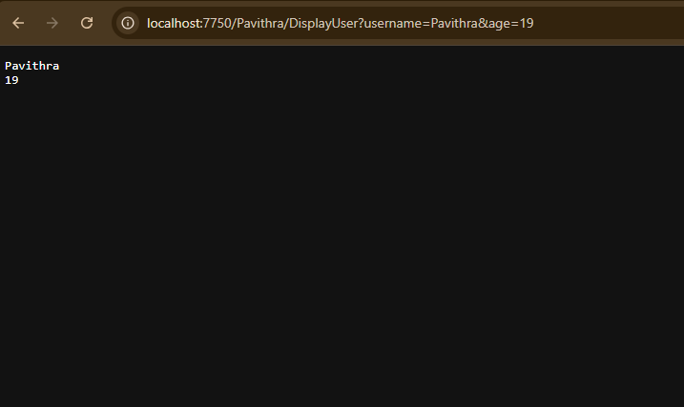

**RESULT:**

Validating the username and age is done successfully and displayed in the browser.